Module End Assignment SQL : E-Commerce Customer Churn
Analysis
Date of Submission : 20 - 09 - 2026
Name : K. Sreelatha

Screen shot:

DATA CLEANING

IMPUTE MEAN FOR THE FOLLOWING COLUMNS, AND ROUND OFF TO THE NEAREST INTEGER IF REQUIRED: WAREHOUSETOHOME, HOURSPENDONAPP, ORDERAMOUNTHIKEFROMLASTYEAR, DAYSINCELASTORDER

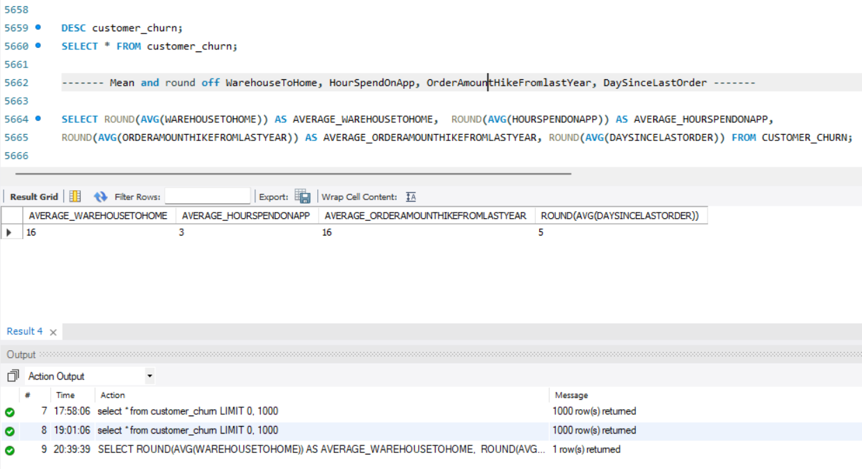

IMPUTE MODE FOR THE FOLLOWING COLUMNS: TENURE, COUPONUSED, ORDERCOUNT

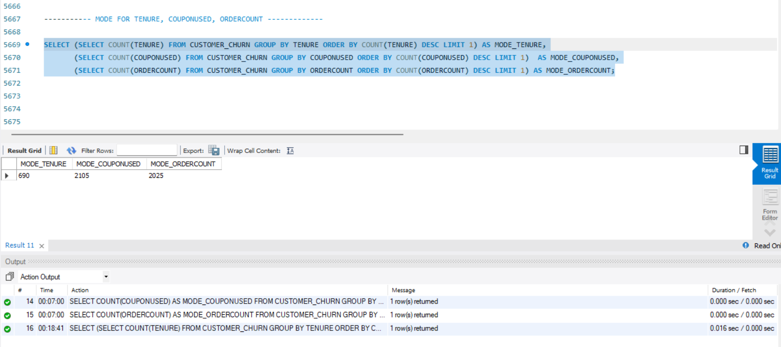

HANDLE OUTLIERS IN THE 'WAREHOUSETOHOME' COLUMN BY DELETING ROWS WHERE THE VALUES ARE GREATER THAN 100

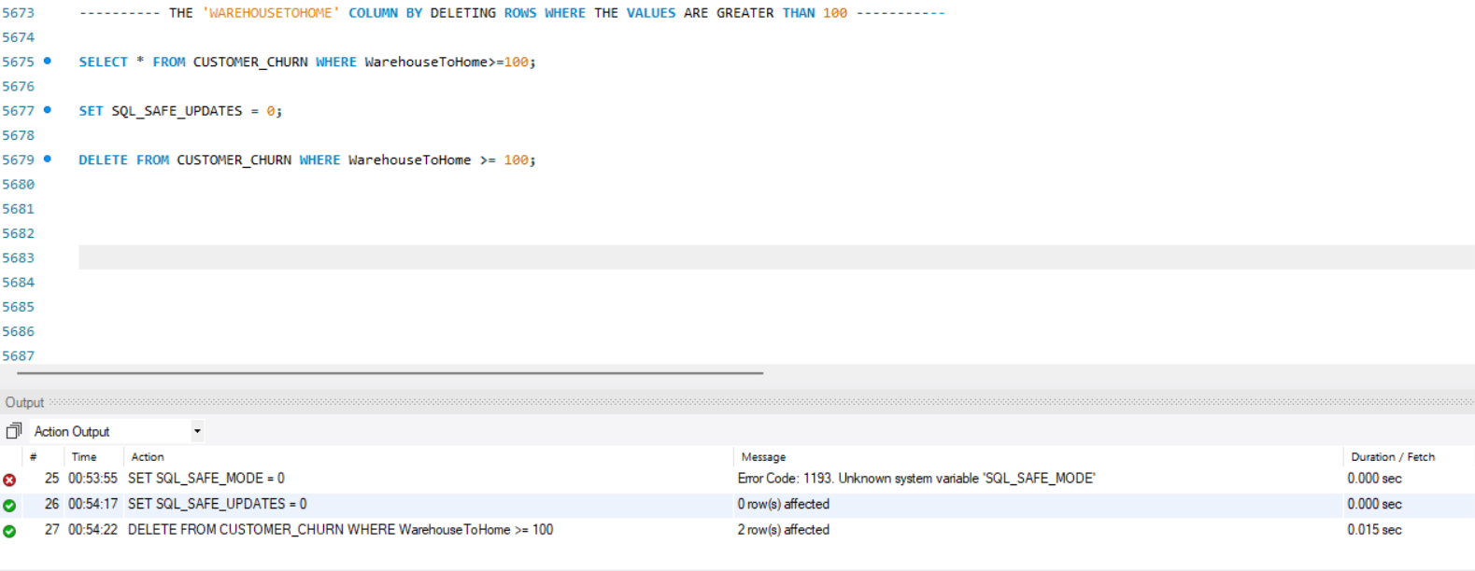
DEALING WITH INCONSISTENCIES

REPLACE OCCURRENCES OF “PHONE” IN THE 'PREFERREDLOGINDEVICE' COLUMN AND “MOBILE” IN THE 'PREFEREDORDERCAT' COLUMN WITH “MOBILE PHONE” TO ENSURE UNIFORMITY

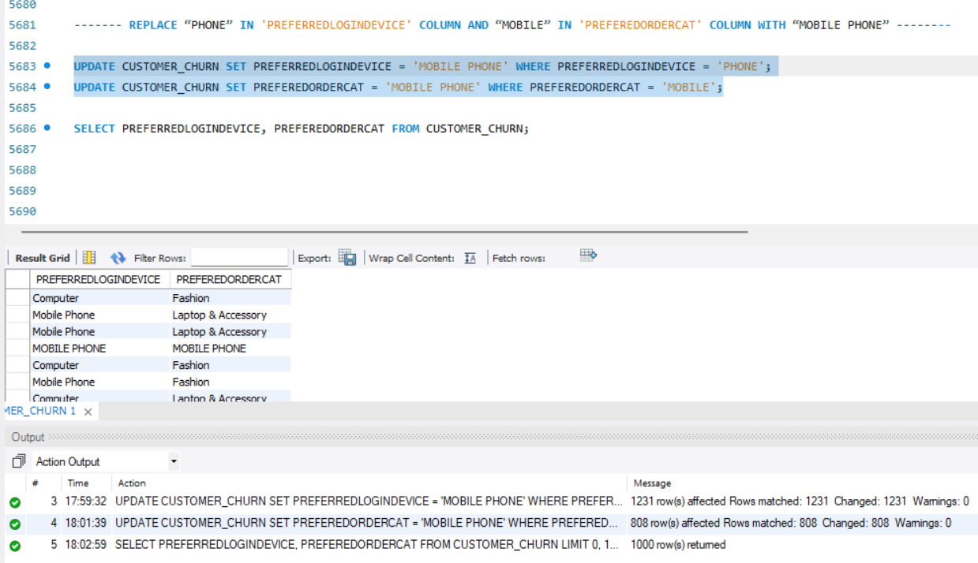

STANDARDIZE PAYMENT MODE VALUES: REPLACE "COD" WITH "CASH ON DELIVERY" AND "CC" WITH "CREDIT CARD" IN THE PREFERREDPAYMENTMODE COLUMN

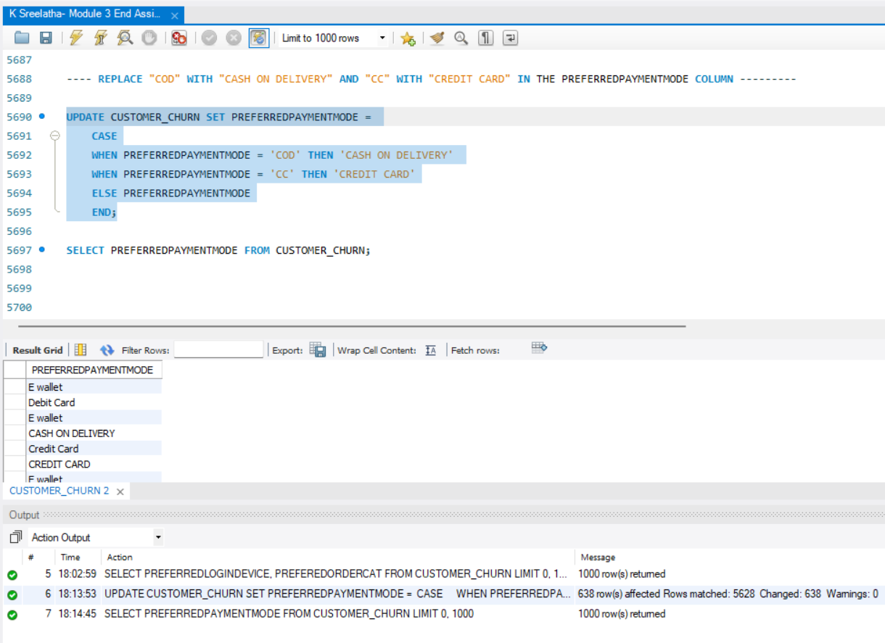

DATA TRANSFORMATION

COLUMN RENAMING
➢ RENAME THE COLUMN "PREFEREDORDERCAT" TO "PREFERREDORDERCAT".
➢ RENAME THE COLUMN "HOURSPENDONAPP" TO "HOURSSPENTONAPP".

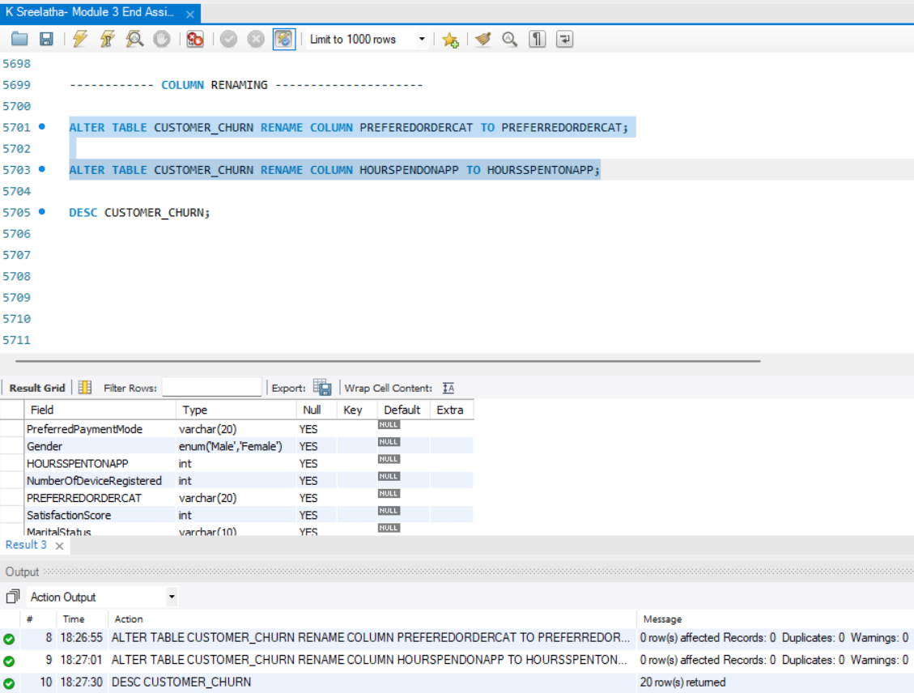

CREATING NEW COLUMNS

CREATE A NEW COLUMN NAMED ‘COMPLAINTRECEIVED’ WITH VALUES "YES" IF THE CORRESPONDING VALUE IN THE ‘COMPLAIN’ IS 1, AND "NO" OTHERWISE.

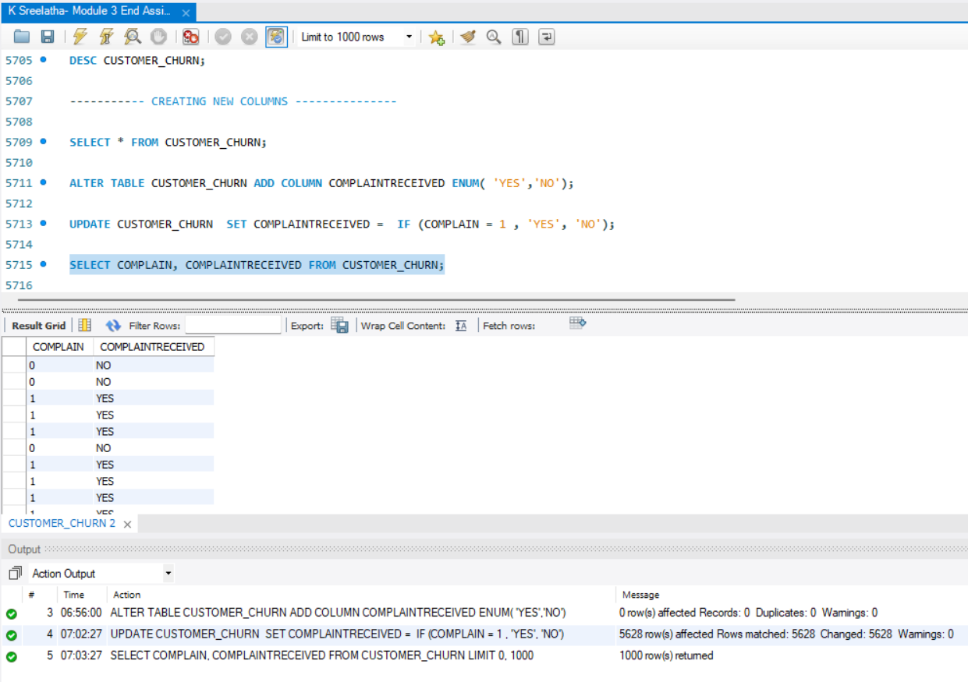

CREATE A NEW COLUMN NAMED 'CHURNSTATUS'. SET ITS VALUE TO “CHURNED” IF THE CORRESPONDING VALUE IN THE 'CHURN' COLUMN IS 1, ELSE ASSIGN “ACTIVE”.

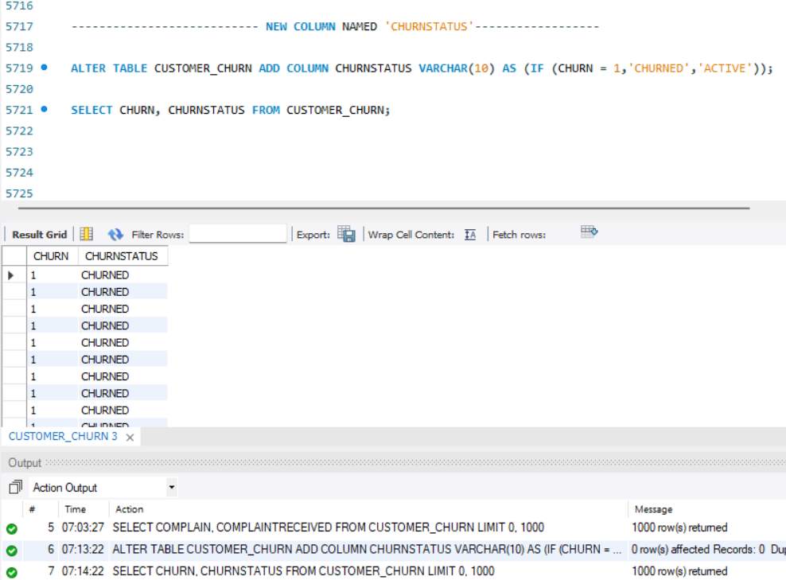

COLUMN DROPPING

DROP THE COLUMNS "CHURN" AND "COMPLAIN" FROM THE TABLE

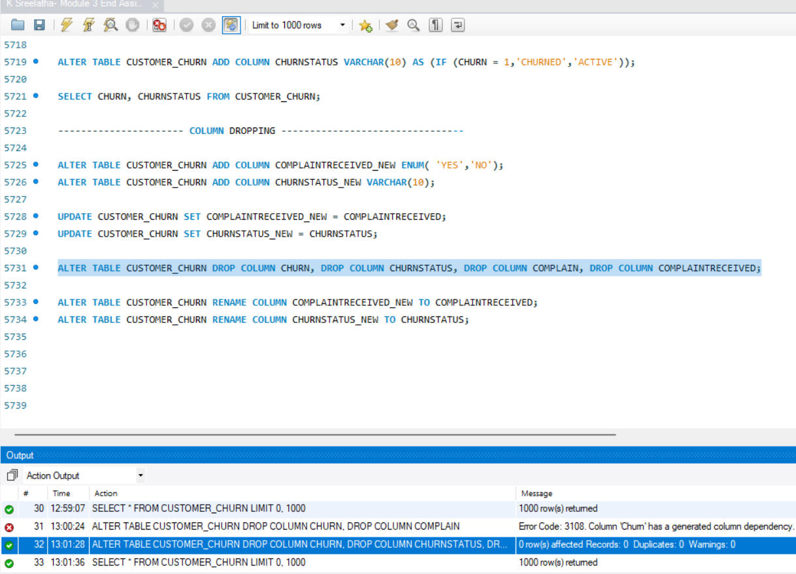

DATA EXPLORATION AND ANALYSIS

RETRIEVE THE COUNT OF CHURNED AND ACTIVE CUSTOMERS FROM THE DATASET

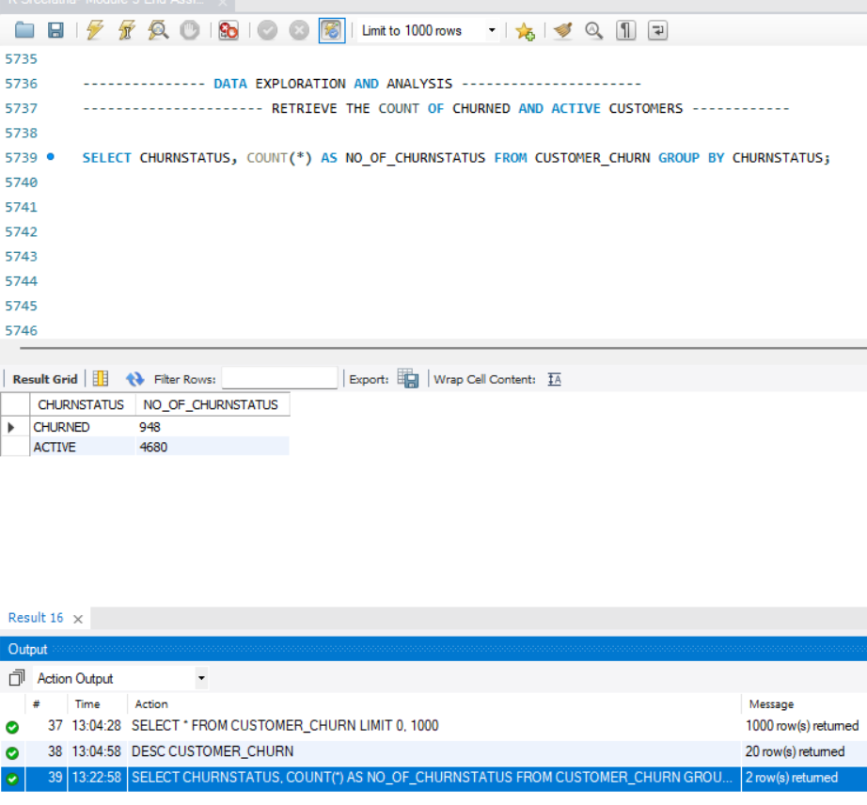

DISPLAY THE AVERAGE TENURE AND TOTAL CASHBACK AMOUNT OF CUSTOMERS WHO CHURNED

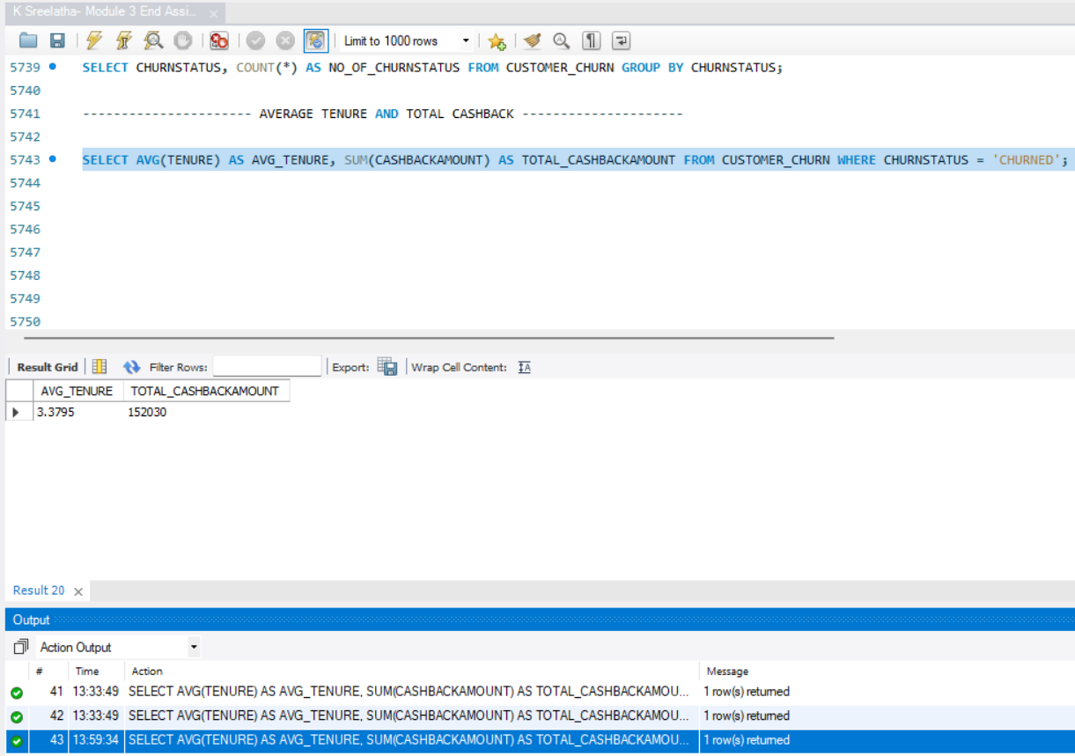

DETERMINE THE PERCENTAGE OF CHURNED CUSTOMERS WHO COMPLAINED

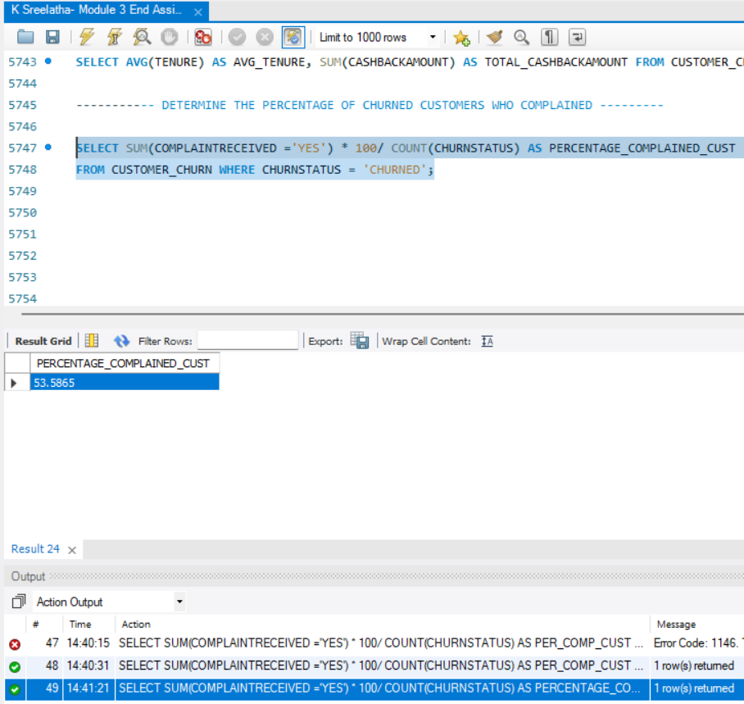

IDENTIFY THE CITY TIER WITH THE HIGHEST NUMBER OF CHURNED CUSTOMERS WHOSE PREFERRED ORDER CATEGORY IS LAPTOP & ACCESSORY

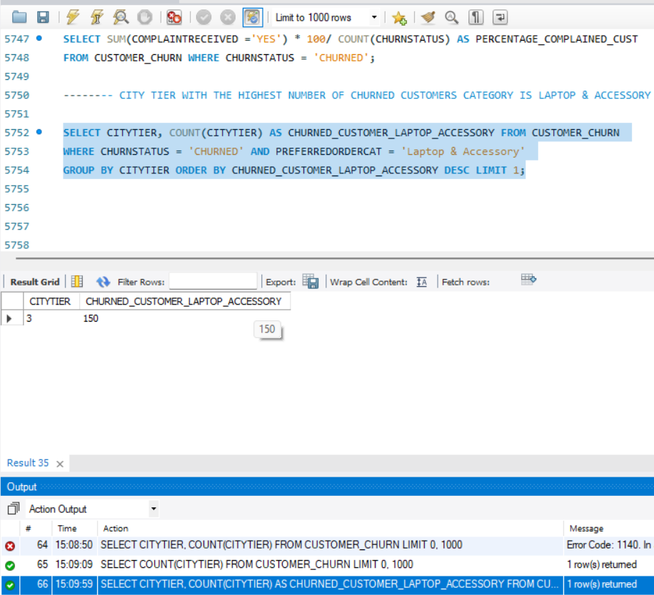

IDENTIFY THE MOST PREFERRED PAYMENT MODE AMONG ACTIVE CUSTOMERS

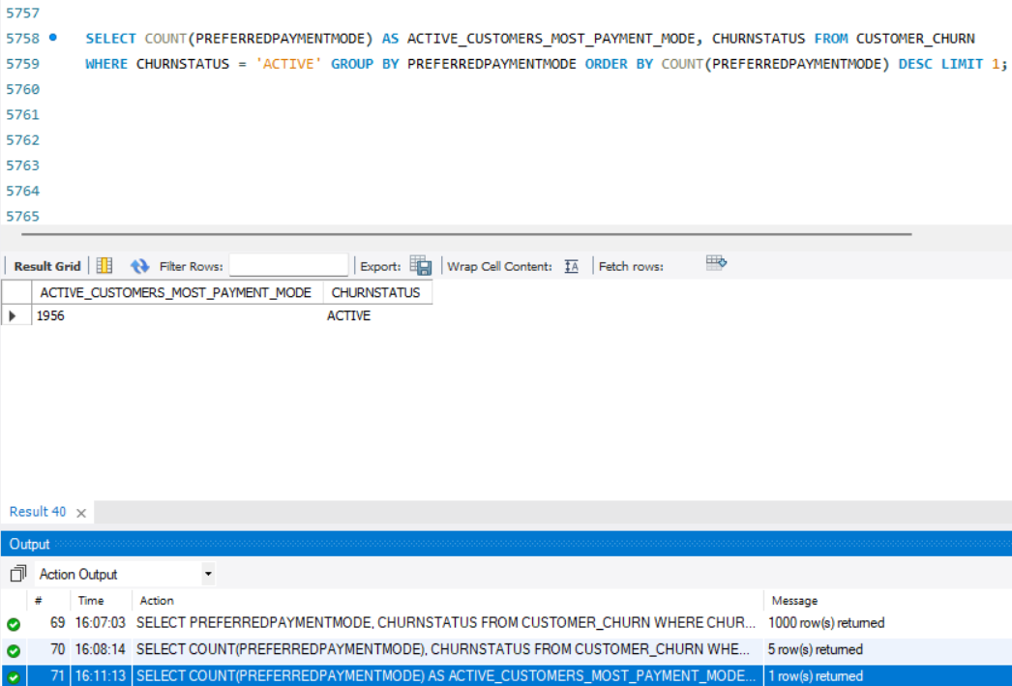

CALCULATE THE TOTAL ORDER AMOUNT HIKE FROM LAST YEAR FOR CUSTOMERS WHO ARE SINGLE AND PREFER MOBILE PHONES FOR ORDERING

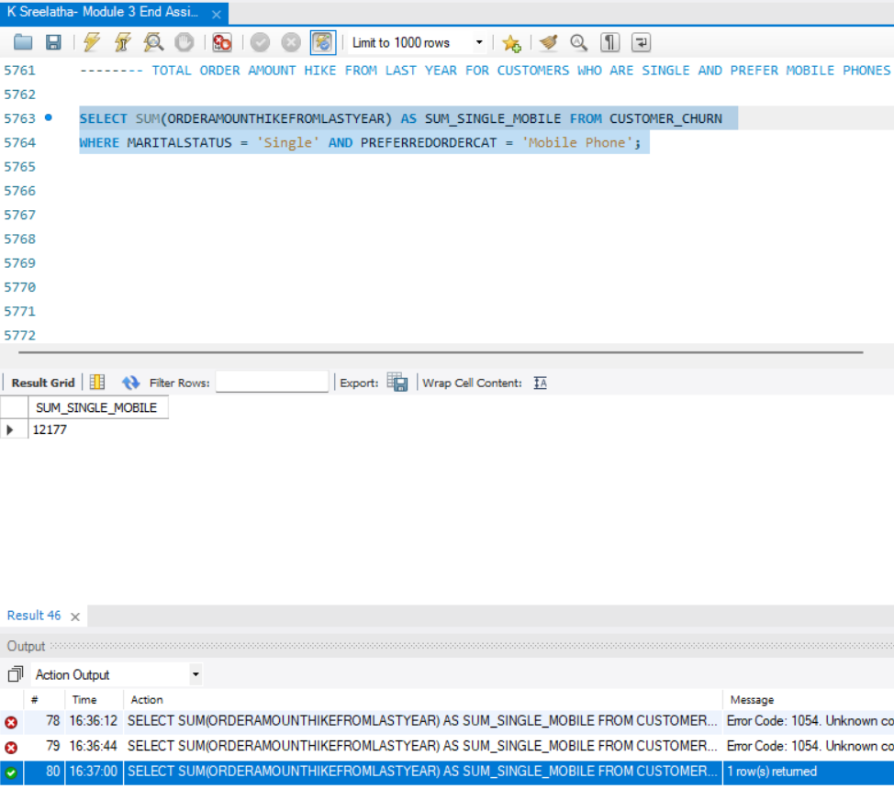

FIND THE AVERAGE NUMBER OF DEVICES REGISTERED AMONG CUSTOMERS WHO USED UPI AS THEIR PREFERRED PAYMENT MODE

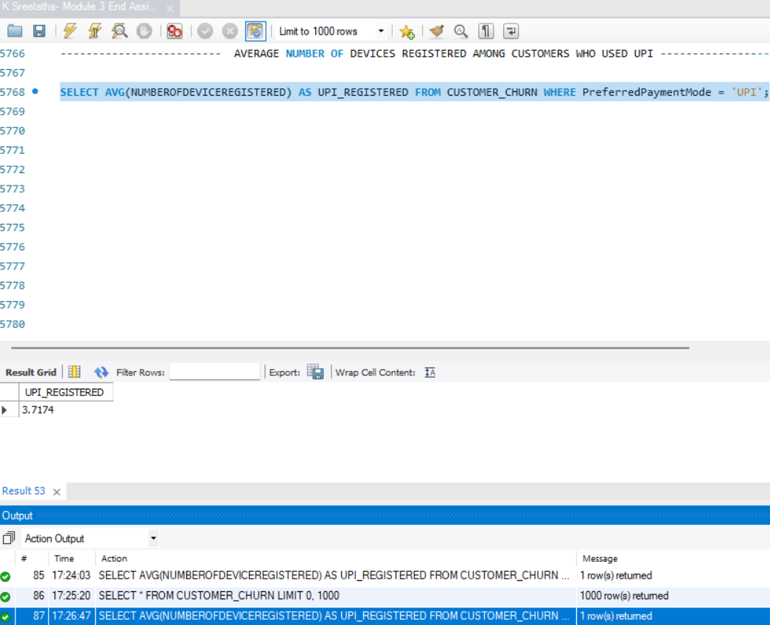

DETERMINE THE CITY TIER WITH THE HIGHEST NUMBER OF CUSTOMERS

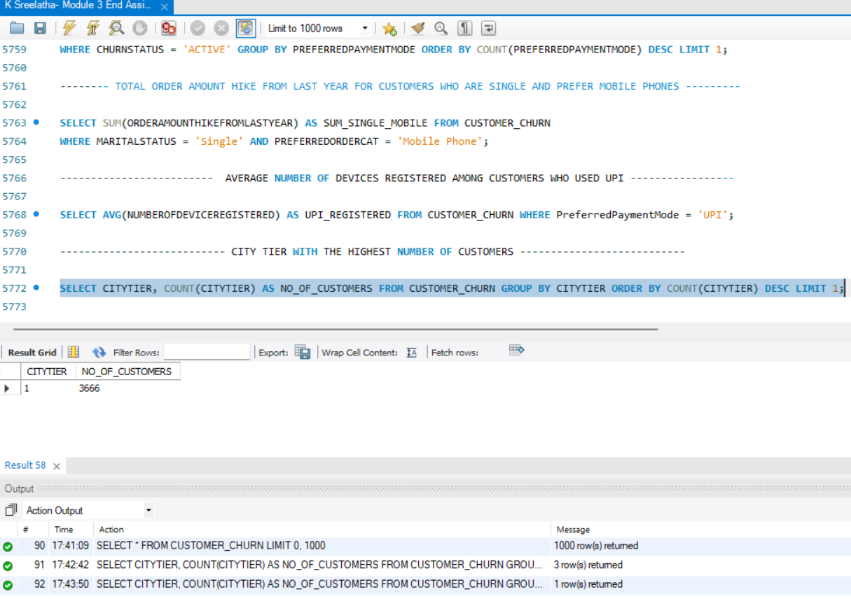

IDENTIFY THE GENDER THAT UTILIZED THE HIGHEST NUMBER OF COUPONS

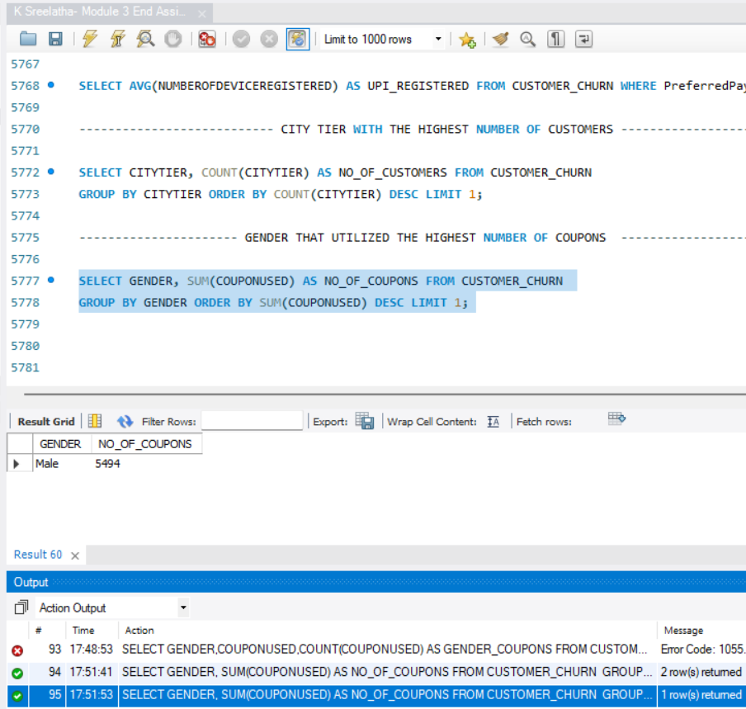

LIST THE NUMBER OF CUSTOMERS AND THE MAXIMUM HOURS SPENT ON THE APP IN EACH PREFERRED ORDER CATEGORY

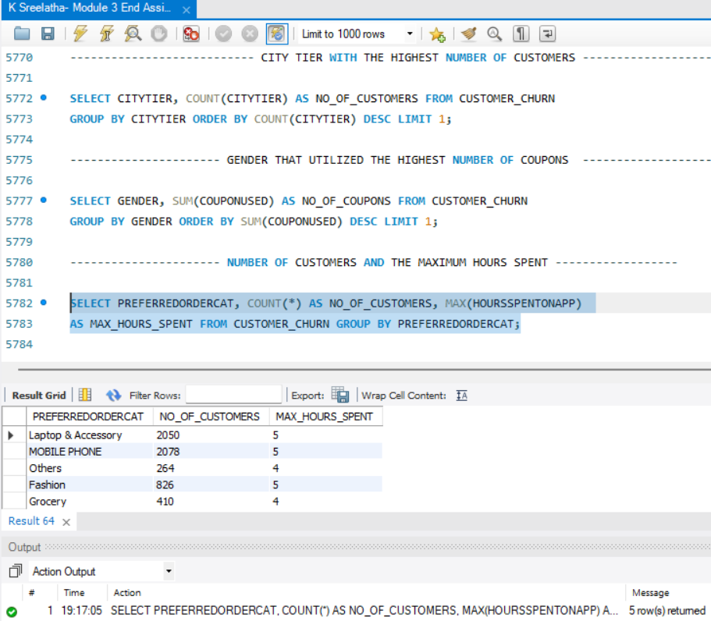

CALCULATE THE TOTAL ORDER COUNT FOR CUSTOMERS WHO PREFER USING CREDIT CARDS AND HAVE THE MAXIMUM SATISFACTION SCORE

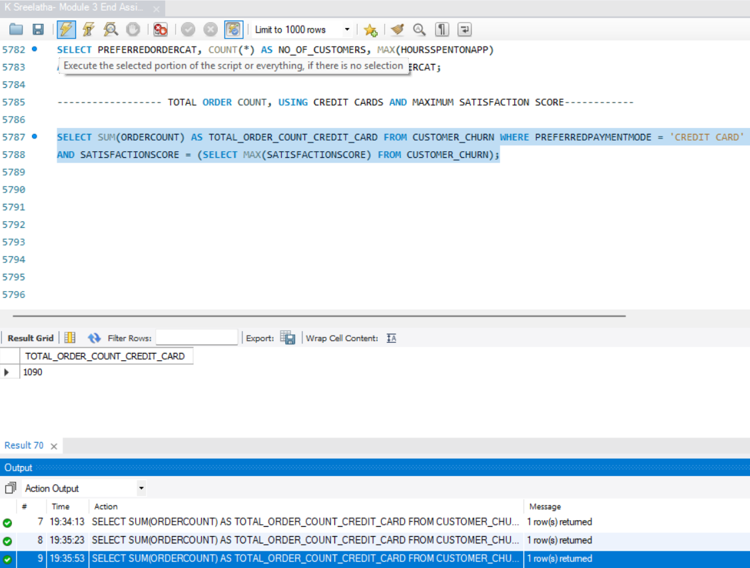

WHAT IS THE AVERAGE SATISFACTION SCORE OF CUSTOMERS WHO HAVE COMPLAINED?

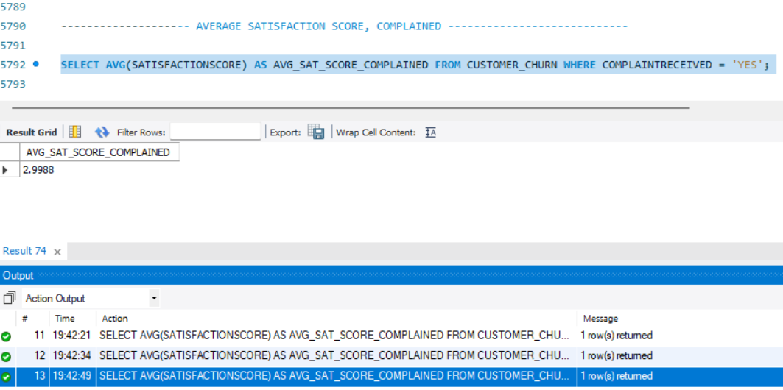
LIST THE PREFERRED ORDER CATEGORY AMONG CUSTOMERS WHO USED MORE THAN 5 COUPONS

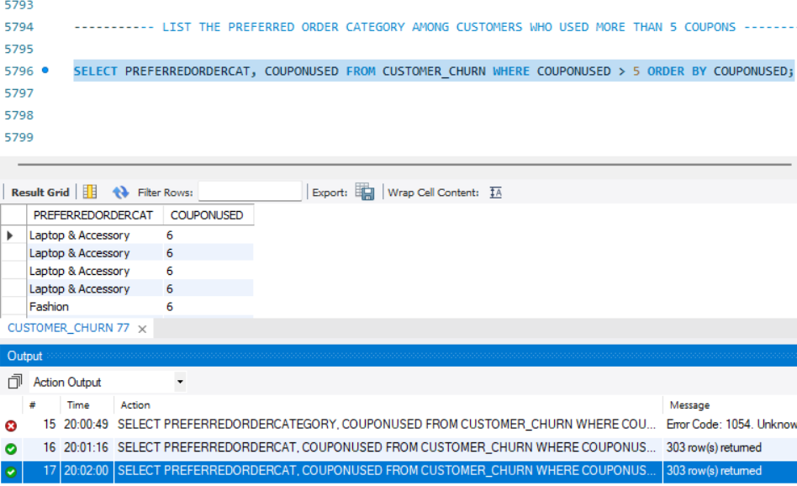

LIST THE TOP 3 PREFERRED ORDER CATEGORIES WITH THE HIGHEST AVERAGE CASHBACK AMOUNT

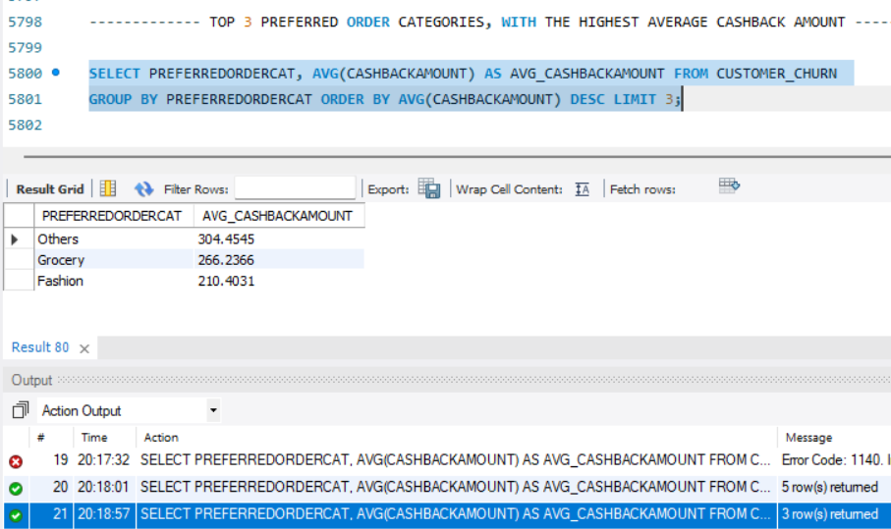
FIND THE PREFERRED PAYMENT MODES OF CUSTOMERS WHOSE AVERAGE TENURE IS 10 MONTHS AND HAVE PLACED MORE THAN 500 ORDERS

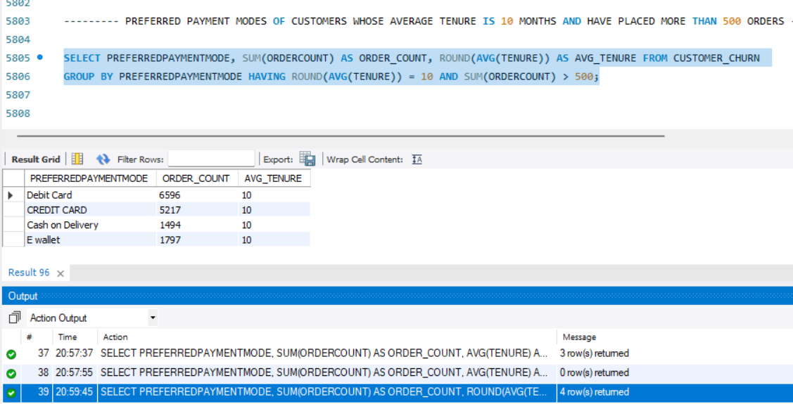

CATEGORIZE CUSTOMERS BASED ON THEIR DISTANCE FROM THE WAREHOUSE TO HOME SUCH AS 'VERY CLOSE DISTANCE' FOR DISTANCES <=5KM, 'CLOSE DISTANCE' FOR <=10KM, 'MODERATE DISTANCE' FOR <=15KM, AND 'FAR DISTANCE' FOR >15KM. THEN, DISPLAY THE CHURN STATUS BREAKDOWN FOR EACH DISTANCE CATEGORY.

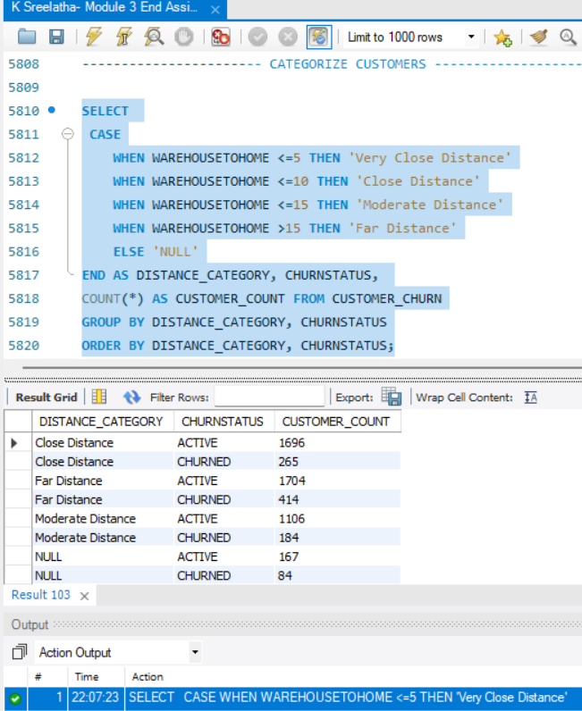

LIST THE CUSTOMER’S ORDER DETAILS WHO ARE MARRIED, LIVE IN CITY TIER-1, AND THEIR ORDER COUNTS ARE MORE THAN THE AVERAGE NUMBER OF ORDERS PLACED BY ALL CUSTOMERS.

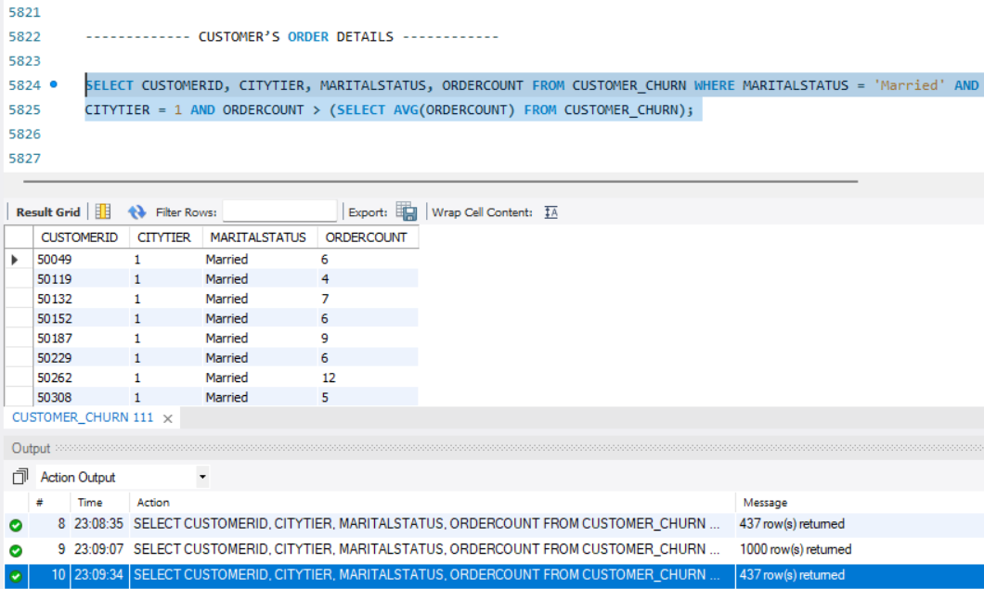

CREATE A ‘CUSTOMER_RETURNS’ TABLE

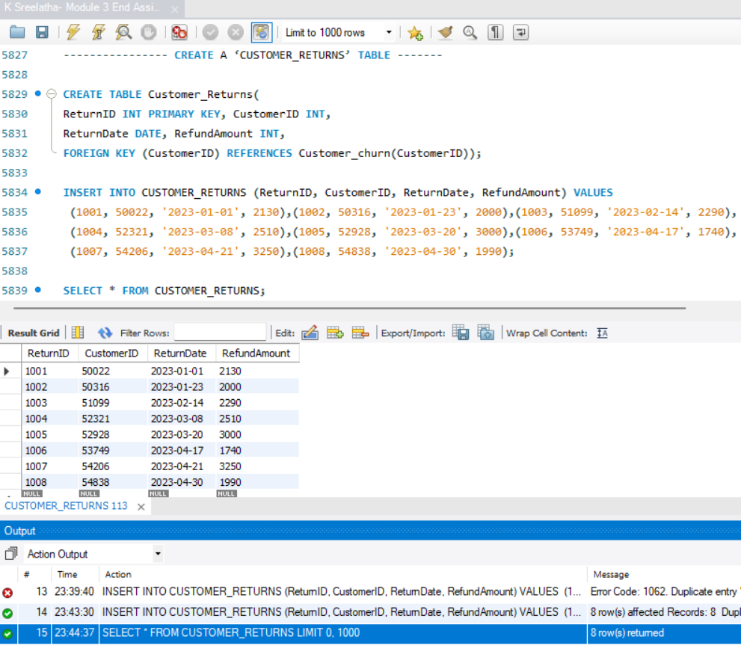

DISPLAY THE RETURN DETAILS ALONG WITH THE CUSTOMER DETAILS OF THOSE WHO HAVE CHURNED AND HAVE MADE COMPLAINTS

